Enclosure 1: Program

Thursday, May 25, 2017 | Welcome
18:00 – 22:00 | Welcome drinks and dinner will be served at Shake and Shake “splav” on the river with a prime view of Kalemegdan Fortress. A combination of a DJ and an open bar should prepare the guests to explore the vibrant riverfront nightclubs that offers something for everyone.  For those preferring to spend the dinner in a more private setting, we highly recommend the following restaurants: Question Mark, Homa, Madera, Three Hats, Comunale, Writers’ Club.
Friday, May 26, 2017 | Discover Belgrade
09:00 – 10:30 | Kalemegdan is Belgrade’s birthplace. Tour of the grounds will include a visit to the Roman well, 18th-century Austrian clock tower, Ottoman mausoleum, 19th-century Slavic half-timbered mansion and a military museum surrounded by old tanks and artillery.  (Free bus transportation to the first location will be provided from Hyatt Hotel, leaving at 8:45)
11:00 – 12:00 | A bus tour for sightseeing will start from Kalemegdan where we will board and set on a tour visiting some of the most important landmarks that Belgrade has to offer. In addition, the tour will thoroughly cover various parts of the city’s history together with an expert tour guide’s narrative.
12:00 – 14:00 | Ada Ciganlija is a river island that has artificially been turned into a peninsula most notable for its beaches and recreational facilities which earned it a nickname “Belgrade’s Sea”. Lunch will include a selection of Balkan specialties, including slowly pot-roasted meat and seafood specialties and an open bar with a wide selection of drinks. | 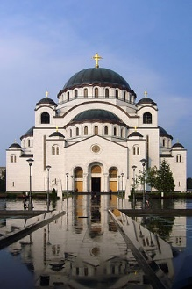
14:30 – 15:15 | Standing at 82 meters, including the cross on the top of the dome, Saint Sava Temple is the largest Orthodox temple in the Balkans, built in the Serbo-Byzantine style. The tour will include a visit to the temple’s crypt, and a walk on the surrounding grounds.
19:00 – 23:00 | We will return to Kalemegdan to visit one of the most iconic restaurants, Kalemegdan Terrace, planted in the side of the fortress overlooking Danube and the Belgrade Zoo, where we will get to experience a traditional Serbian welcome. Following the dinner, entertainment will be provided by a live band that should, together with an open bar, get everyone ready for the prime night of clubbing in the city.  (Free bus transportation will be provided from Hyatt Hotel, leaving at 18:45)
Saturday, May 27, 2017 | Main Program
09:30 – 11:30 | Cruise in a privately chartered boat on the Sava and Danube rivers to explore the city from a different perspective (drinks and snacks served).  (Free bus transportation to the first location will be provided from Hyatt Hotel, leaving at 9:15)
12:00 – 17:30 | The program begins with a tour of the House of the National Assembly (12:00-13:00) that will act as a guide through history, from the Kingdom of Serbia, through the Socialist Federal Republic of Yugoslavia all the way to present day. The session will also include a light brunch and a selection of drinks. | 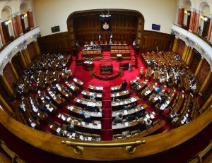
20:00 – 01:00 | The Royal Palaces complex with its magnificent views towards the ridge of Dedinje Hill, Koshutnjak Forest, Topchider and Avala Mountain represents the perfect backdrop for the European celebration of 200 years of Harvard Law School. Following a reception from the Royal family and a group photoshoot, the Association will host the awards ceremony. This year’s keynote address will be delivered by the Serbian Prime Minister, Mr. Aleksandar Vučić.  (Free bus transportation will be provided from Hyatt Hotel, leaving at 19:30) | 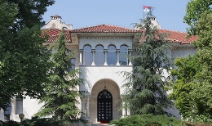
Sunday, May 28, 2017 | Farewell
10:30 – 13:30 | Farewell brunch will be held at the Top of the Hub restaurant with a 360 degree panorama of the city. With the city as the backdrop, the restaurant will serve as a perfect setting to share closing remarks, exchange impressions and bid farewell.  (Hyatt will provide shuttles for the guests to the Nikola Tesla Airport) | 